
RAMAIAH
INSTITUTE OF TECHNOLOGY
USN | 1 | M | S

(Autonomous Institute, Affiliated to VTU)
(Approved by AICTE, New Delhi & Govt. of Karnataka) Accredited by NBA & NAAC with ‘A’ Grade

MAKEUP EXAMINATIONS – FEBRUARY 2018

Course & Branch | : | B.E. : Electrical and Electronics Engineering | Semester | : | V
Subject | : | Control Systems | Max. Marks | : | 100
Subject Code | : | EE52/EE502 | Duration | : | 3 Hrs

Instructions to the Candidates:
- Answer one full question from each unit

 |  | UNIT- I
1. | a) | Obtain i) F-V and ii) F-I analogous circuit of the following mechanical system.  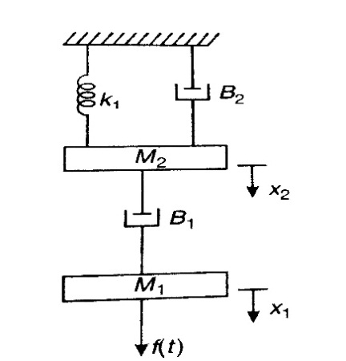  Fig.1(a) | CO1 | (12)
 | b) | What are the advantages of having feedback in a control system? Explain with at least 2 examples with respective block diagrams. | CO1 | (08)
2. | a) | Obtain the transfer function of the following circuit diagram.  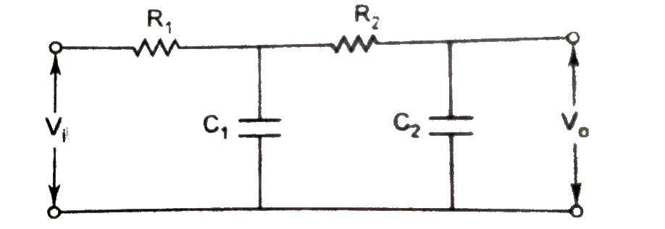  Fig.2(a) | CO1 | (10)
 | b) | Obtain i) F-V and ii) F-I analogous circuit of the following mechanical system.  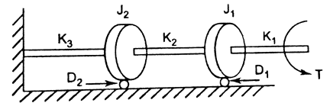  Fig.2(b) | CO1 | (10)
 |  | UNIT- II
3. | a) | Define: i) Peak Overshoot ii) Peak Time with respect to an under damped system. Hence derive the expression for the same. | CO2 | (10)
 | b) | Consider a unity feedback system with a closed t.f.  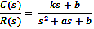  Determine the open-loop transfer function. G(s). Show that the steady-state error with unit ramp input is given as . | CO2 | (10)
4. | a) | Obtain the transfer function 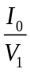from following circuit diagram.  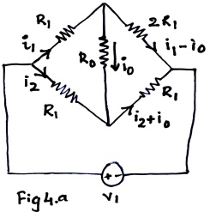 | CO2 | (12)
 | b) | Find step, ramp and parabolic error coefficients and their corresponding steady-state error for unity feedback system having transfer function.  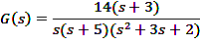 | CO2 | (08)
 |  | UNIT- III
5. | a) | State and explain RH criterion of stability. What are its limitations? | CO3 | (08)
 | b) | Plot the root locus of the system with OLTF 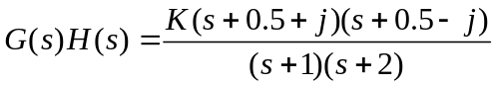, Show that part of root locus of system is a circle. | CO3 | (12)
6. | a) | How the roots of the characteristic equation are related to stability? | CO3 | (06)
 | b) | Sketch the root locus plot and find stability for a unity feedback system whose OLTF is given as G(s)=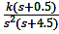. Find the range of K for which the system is stable. | CO3 | (14)
 |  | UNIT- IV
7. | a) | Define:  - Resonant peak  - Resonant frequency  - Bandwidth  - Cut off rate. | CO4 | (08)
 | b) | A unity negative feedback system is characterized by,  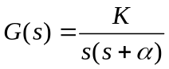.  Find the values of K and so that 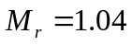and 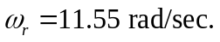 | CO4 | (12)
8. | a) | Sketch the Nyquist plot and determine the stability of the following open loop transfer function of unity feedback control system 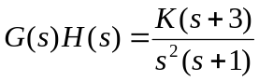. | CO3 | (10)
 | b) | For 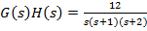, sketch Nyquist plot and determine the stability of the system . Calculate GM of the system. | CO3 | (10)
 |  | UNIT- V
9. | a) | Obtain the transfer function of the system whose Bode plot is as shown below.  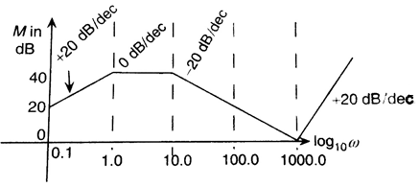  Fig.9(a) | CO4 | (10)
 | b) | Obtain the transfer function of a lag compensator for φ_{m} = - 40⁰ and f_{m} = 5KHz. Assume C = 10nF. Also find the corner frequencies. | CO5 | (10)
10. | a) | Obtain the Bode plot of a unity negative feedback system, whose OLTF is . Hence, find the stability of the system. | CO4 | (12)
 | b) | Obtain the transfer function of a lead compensator for φ_{m} = 35⁰ and f_{m} = 4kHz. Assume C=20nF. | CO5 | (08)

****************

